UNIVERSIDAD DE SAN CARLOS DE GUATEMALA

CENTRO UNIVERSITARIO DE OCCIDENTE

LENGUAJES FORMALES Y DE PROGRAMACIÓN

SECCIÓN A

INGENIERO OLIVER SIERRA

**Practica 2**

MARÍA JOSÉ BAQUIAX RODRÍGUEZ, 201831422

OCTUBRE DEL AÑO 2021

INGENIERÍA EN CIENCIAS Y SISTEMAS

MANUAL TÉCNICO

Herramientas

Apache NetBeans

Requerimientos para su instalación

-Una computadora de escritorio con al menos 2 GB de RAM.

-Se requiere Java SE Development Kit (JDK) 8, 11 o 14 para usar NetBeans IDE (NetBeans no continúa JDK9)

Sistemas operativos compatibles

Windows, Mac OSX, Linux y BSD.

Requerimientos para dar funcionamiento al programa

Tener instalado previamente Apache Netbeans con todas sus funcionalidades

Lenguaje java

Java es un lenguaje de programación y una plataforma informática comercializada por primera vez en 1995 por Sun Microsystems. Hay muchas aplicaciones y sitios web que no funcionarán a menos que tenga Java instalado y cada día se crean más. Java es rápido, seguro y fiable. Desde portátiles hasta centros de datos, desde consolas para juegos hasta súper computadoras, desde teléfonos móviles hasta Internet, Java está en todas partes.[1]

Autómatas finitos

Podríamos definir un autómata como una máquina de estados y transiciones dentro de la cual se tienen estados de aceptación y transiciones de un estado a otro siguiendo las reglas establecidas para [grafos dirigidos](https://es.wikipedia.org/wiki/Grafo_dirigido). Dichos estados de aceptación dentro del autómata “reconocen” que es posible aceptar una cadena de entrada, porque cumple con una definición en el alfabeto.[2]

El modelo matemático de un automata consta de cinco elementos que son:

* **Q**= un conjunto finito de estados
* Σ= un conjunto finito de símbolos de entrada
* ***S0***= un estado inicial
* ***F***= un conjunto de estados finales
* ∂= una función de transición

Autómatas de pila

Existe un tipo de autómata que define los lenguajes independientes del contexto. Dicho autómata, conocido como “autómata de pila”, es una extensión del autómata finito no determinista con transiciones-ε , el cual constituye una forma de definir los lenguajes regulares. El autómata de pila es fundamentalmente un AFN-ε con la adición de una pila. La pila se puede leer, se pueden introducir elementos en ella y extraer sólo el elemento que está en la parte superior de la misma, exactamente igual que la estructura de datos de una “pila”.[3]

ANALISIS LEXICO

Numero entero: [-] ? [/d]+ 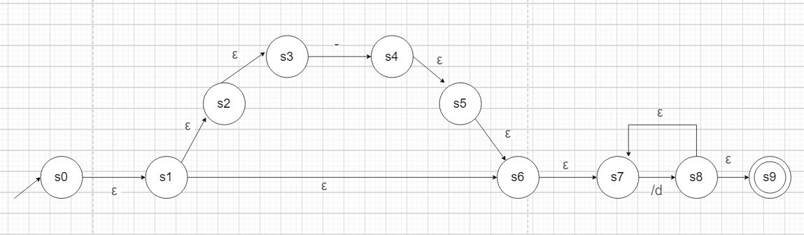

TABLA DE TRANSICIÓN

|  |  |  |  |
| --- | --- | --- | --- |
| FT función de transición | ε | - | / d |
| S0 | A = s1,s2,s3,s6,s7 | ∂(A,-) = s4 | ∂(A, / d) = s8 |
| S4 | B = s5,s6,s7 | ∂(B,-) = { } | ∂(B, / d) = s8 |
| S8 | C = s7,s9 | ∂(C,-) = { } | ∂(C, / d) = s8 |

|  |  |  |  |  |  |  |  |
| --- | --- | --- | --- | --- | --- | --- | --- |
| Q = | A,B,C |  | ∂(A, -) = | B |  |  |  |
| S0 = | A |  | ∂(A, / d) = | C |  |  |  |
| Σ = | ( - ), /d (0-9) |  | ∂(B, / d) = | C |  |  |  |
| F = | C |  | ∂(C, / d) = | C |  |  |  |

OPTIMIZACION DEFINICIÓN FORMAL

|  |  |  |
| --- | --- | --- |
|  | - | / d |
| A | B | C |
| B |  | C |
| C |  | C |

AUTOMATA FINITO DETERMINISTA

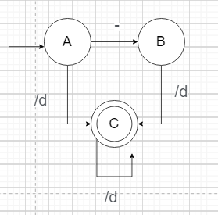

Identificador: { ( _ ) | (/l) } { (/l)* (/d)* (-)* ( _ )* }

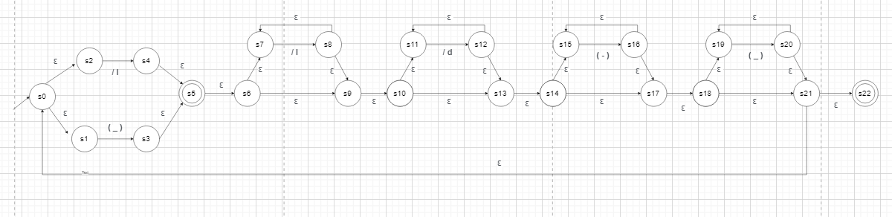

TABLA DE TRANSICIÓN

|  |  |  |  |  |  |
| --- | --- | --- | --- | --- | --- |
| FT función de transición | ε | ( _ ) | / l | /d | (-) |
| S0 | A = s1,s2 | ∂(A,_) = s3 | ∂(A, / l) = s4 | ∂(A, / d) = { } | ∂(A, - ) = { } |
| S3,s4 | B = s5,s6,s7,  s9,s10,s11,  s13,s14,s15,  s17,s18,s19,  s21,s22,s1,s2 | ∂(B,_) = s20,  S3 | ∂(B, / l) = s8 | ∂(B, / d) =s12 | ∂(B, - ) = s16 |
| S8 | C =s9,s10,s11,  s13,s14,s15,  s17,s18,s19,  s21,s22,s1,s2,s7 | ∂(C,_) = s20,  S3 | ∂(C, / l) = s4,  S8 | ∂(C, / d) =s12 | ∂(C, - ) =s16 |
| S12 | D=s13,s14,s15,  s17,s18,s19,  s21,s22,s1,s2,s11 | ∂(D,_) =s20,  S3 | ∂(D,/l) =s4 | ∂(D,/d)={s12} | ∂(D,-) =s16 |
| S16 | E=s17,s18,s19,  s21,s22,s1,s2,s15 | ∂(E,_)=s20,  S3 | ∂(E,/l)=s4 | ∂(E,/d)= | ∂(E,-)=s16 |
| S20 | F=s19,s21,s22,  s1,s2 | ∂(F,_)=s20,  S3 | ∂(F,/l)= | ∂(F,/d)= | ∂(F,-)= |

|  |  |  |  |  |  |  |  |
| --- | --- | --- | --- | --- | --- | --- | --- |
| Q = | A,B,C,D,E |  | ∂(A, _) = | B |  | ∂(C, / l) = | C |
| S0 = | A |  | ∂(A,_) = | C |  | ∂(C, /d) = | D |
| Σ = | ( _ ), /l (a-zA-Z), /d (0-9), ( - ) |  | ∂(B, _) = | B |  | ∂(C, -) = | E |
| F = | B,F |  | ∂(B, / l) = | C |  | ∂(D, _) = | B |
|  |  |  | ∂(B, /d) = | D |  | ∂(D, / l) = | C |
|  |  |  | ∂(B, -) = | E |  | ∂(D, /d) = | D |
|  |  |  | ∂(C, _) = | B |  | ∂(D, -) = | E |

OPTIMIZACION DEFINICIÓN FORMAL

|  |  |  |  |  |
| --- | --- | --- | --- | --- |
|  | _ | / l | /d | - |
| A | B | C |  |  |
| B | B | C | D | E |
| C | B | C | D | E |
| D | B | C | D | E |
| E | B | C |  | E |
| F | B |  |  |  |

|  |  |
| --- | --- |
| ∂(F, _) = | B |
|  |  |
|  |  |
|  |  |

|  |  |
| --- | --- |
| ∂(E, _) = | B |
| ∂(E, / l) = | C |
| ∂(E, /d) = |  |
| ∂(E, -) = | E |

AUTOMATA FINITO DETERMINISTA

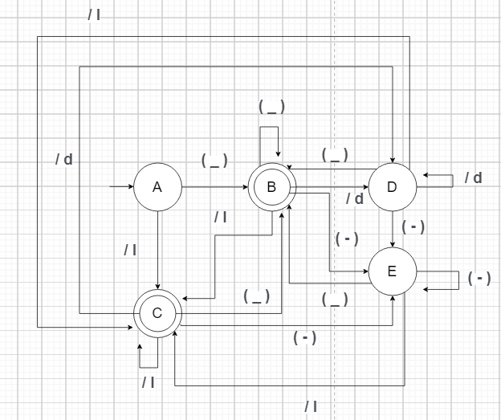

Palabras reservadas: ( palabra )?

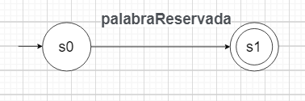

TABLA DE TRANSICIÓN

|  |  |  |
| --- | --- | --- |
| FT función de transición | ε | palabraReservada |
| S0 | A = { } | ∂(A,pR) = s1 |

OPTIMIZACION DEFINICIÓN FORMAL

|  |  |  |
| --- | --- | --- |
|  | pR |  |
| A | B |  |
|  |  |  |
|  |  |  |

|  |  |  |  |  |  |  |  |
| --- | --- | --- | --- | --- | --- | --- | --- |
| Q = | A,B, |  | ∂(A, pR) = | B |  |  |  |
| S0 = | A |  |  |  |  |  |  |
| Σ = | palabraReservada =  ( ESCRIBIR, FIN, REPETIR, INICIAR, SI, VERDADERO, FALSO, ENTONCES) |  |  |  |  |  |  |
| F = | B |  |  |  |  |  |  |

AUTOMATA FINITO DETERMINISTA

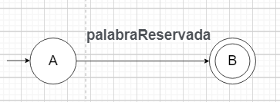

Literal: [“] ( . +) [”]

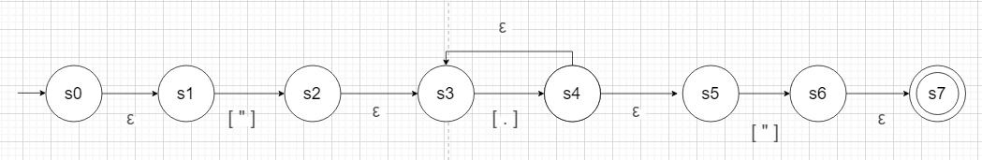

TABLA DE TRANSICIÓN

|  |  |  |  |  |
| --- | --- | --- | --- | --- |
| FT función de transición | ε | “ | . | ” |
| S0 | A = s1 | ∂(A,-) = s2 | ∂(A, . ) = { } | ∂(A, / d) = { } |
| S2 | B = s3 | ∂(B,-) = { } | ∂(B, . ) = s4 | ∂(B, / d) = { } |
| S4 | C = s3,s5 | ∂(C,-) = { } | ∂(C, . ) = s4 | ∂(C, / d) = s6 |
| S6 | D = s7 |  |  |  |

OPTIMIZACION DEFINICIÓN FORMAL

|  |  |  |  |
| --- | --- | --- | --- |
|  | “ | . | ” |
| A | B |  |  |
| B |  | C |  |
| C |  | C | D |

|  |  |  |  |  |  |  |  |
| --- | --- | --- | --- | --- | --- | --- | --- |
| Q = | A,B,C,D |  | ∂(A, “) = | B |  |  |  |
| S0 = | A |  | ∂(B, .) = | C |  |  |  |
| Σ = | [ “ ], [.] (cualquier símbolo), [ ” ] |  | ∂(C, .) = | C |  |  |  |
| F = | D |  | ∂(C, ”) = | D |  |  |  |

AUTOMATA FINITO DETERMINISTA

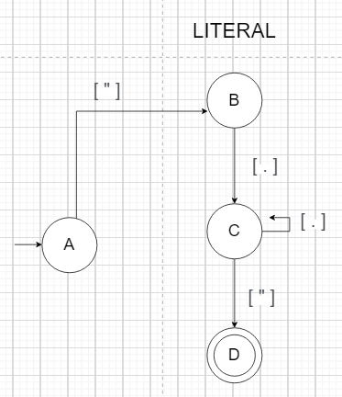

Comentarios: [ \ ] [ \ ] [ . ] 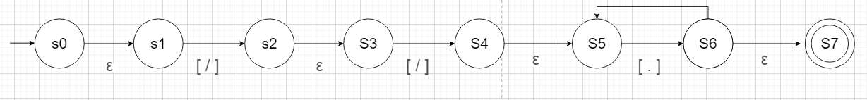

TABLA DE TRANSICIÓN

|  |  |  |  |
| --- | --- | --- | --- |
| FT función de transición | ε | / | . |
| S0 | A = s1 | ∂(A,/) = s2 | ∂(A, . ) = { } |
| S2 | B = s3 | ∂(B,/) = s4 | ∂(B, . ) = s4 |
| S4 | C = s5 | ∂(C,/) = { } | ∂(C, . ) = s6 |
| S6 | D = s5,s7 | ∂(D,/) = { } | ∂(D, . ) = s6 |

OPTIMIZACION DEFINICIÓN FORMAL

|  |  |  |
| --- | --- | --- |
|  | / | . |
| A | B |  |
| B | B | C |
| C |  | C |
|  |  |  |

|  |  |  |  |  |  |  |  |
| --- | --- | --- | --- | --- | --- | --- | --- |
| Q = | A,B,C,D |  | ∂(A, /) = | B |  | ∂(D, . ) | C |
| S0 = | A |  | ∂(B, /) = | B |  |  |  |
| Σ = | [ / ], [ . ] (cualquier símbolo) |  | ∂(B, .) = | C |  |  |  |
| F = | C |  | ∂(C, .) = | C |  |  |  |

AUTOMATA FINITO DETERMINISTA

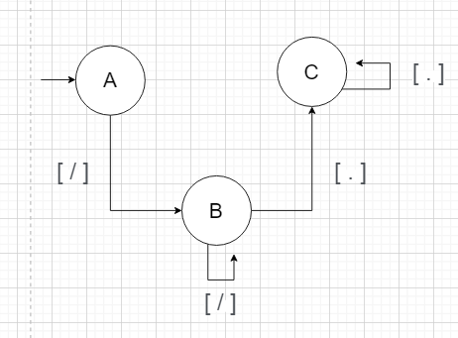

Caracteres especiales: caracter*

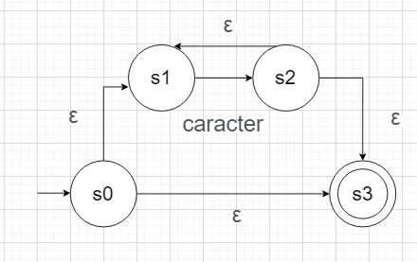

TABLA DE TRANSICIÓN

|  |  |  |
| --- | --- | --- |
| FT función de transición | ε | caracter |
| S0 | A = s1,s3 | ∂(A,c) = s2 |
| S2 | B = s1,s3 | ∂(B,c) = s2 |

OPTIMIZACION DEFINICIÓN FORMAL

|  |  |
| --- | --- |
|  | caracter |
| A | B |
| B | B |
|  |  |
|  |  |

|  |  |  |  |  |  |  |  |
| --- | --- | --- | --- | --- | --- | --- | --- |
| Q = | A,B |  | ∂(A, c) = | B |  |  |  |
| S0 = | A |  | ∂(B, c) = | B |  |  |  |
| Σ = | [ caracter ] (espacio, salto de línea ( \n ), tabulaciones ( \t ), retorno de carro ( \r ), salto de página ( \f )) |  |  |  |  |  |  |
| F = | B |  |  |  |  |  |  |

AUTOMATA FINITO DETERMINISTA

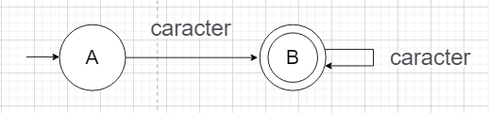

AUTOMATA GENERAL

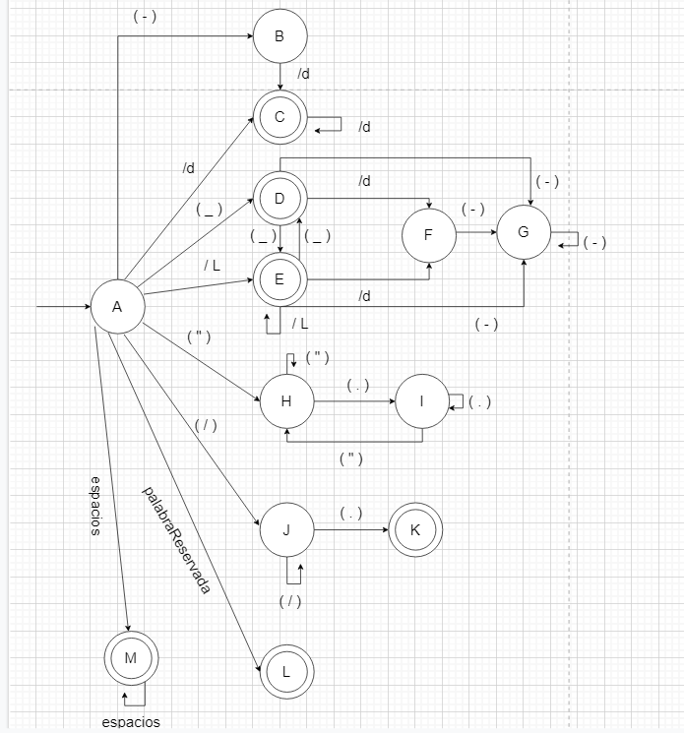

GRAMÁTICA

Estructura ESCRITURA

|  |  |  |
| --- | --- | --- |
| PRODUCCIONES | | |
| (E) |  | ESCRIBIR V F |
| (V) |  | LITERAL | NUMERO | IDENTIFICADOR |
| (F) |  | FIN |
|  |  |  |

|  |  |  |
| --- | --- | --- |
| PRIMEROS | | |
| P(E) |  | {ESCRIBIR} |
| P(V) |  | (LITERAL, NUMERO, IDENTIFICADOR} |
| P(F) |  | {FIN} |
|  |  |  |

|  |  |  |
| --- | --- | --- |
| SIGUIENTES | | |
| S(E) |  | (LITERAL, NUMERO, IDENTIFICADOR} |
| S(V) |  | {FIN} |
| S(F) |  | {$} |
|  |  |  |

|  |  |  |  |  |  |  |  |
| --- | --- | --- | --- | --- | --- | --- | --- |
| ANALISIS | | | | | | | |
|  | ESCRIBIR | LITERAL | NUMERO | IDENTIFICADOR | FIN | $ |  |
| E | ESCRIBIR L F |  |  |  |  |  |  |
| V |  | LITERAL | NUMERO | IDENTIFICADOR |  |  |  |
| F |  |  |  |  | FIN |  |  |
|  |  |  |  |  |  |  |  |

Estructura REPETIR

|  |  |  |
| --- | --- | --- |
| PRODUCCIONES | | |
| (R) |  | REPERIR V INICIAR T F |
| (V) |  | NUMERO | IDENTIFICADOR |
| (C) |  | ESCRITURA C | ε |
| (F) |  | FIN |

|  |  |  |
| --- | --- | --- |
| PRIMEROS | | |
| P(R) |  | {REPETIR} |
| P(V) |  | (NUMERO | IDENTIFICADOR} |
| P(C) |  | { ESCRITURA, ε} |
| P(F) |  | {FIN} |

|  |  |  |
| --- | --- | --- |
| SIGUIENTES | | |
| S(R) |  | (NUMERO | IDENTIFICADOR} |
| S(V) |  | {INICIAR} |
| S(C) |  | {FIN} |
| S(F) |  | {$} |

|  |  |  |  |  |  |  |  |
| --- | --- | --- | --- | --- | --- | --- | --- |
| ANALISIS | | | | | | | |
|  | REPETIR | NUMERO | IDENTIFICADOR | INICIAR | ESCRITURA | FIN | $ |
| R | REPETIR INICIAR T F |  |  |  |  |  |  |
| V |  | NUMERO | IDENTIFICADOR |  |  |  |  |
| C |  |  |  |  | ESCRITURA | ε |  |
| F |  |  |  |  |  | FIN |  |

Estructura CONDICIONAL

|  |  |  |
| --- | --- | --- |
| PRODUCCIONES | | |
| (C) |  | SI P ENTONCES E F |
| (P) |  | VERDADERO | FALSO |
| (E) |  | ESCRITURA | ε |
| (F) |  | FIN F | ε |

|  |  |  |
| --- | --- | --- |
| PRIMEROS | | |
| P(C) |  | {SI} |
| P(P) |  | (ESCRITURA | ε} |
| P(E) |  | { VERDADERO | FALSO} |
| P(F) |  | {FIN} |

|  |  |  |
| --- | --- | --- |
| SIGUIENTES | | |
| S(C) |  | ($} |
| S(P) |  | {FIN, $} |
| S(E) |  | {ENTONCES} |
| S(F) |  | {$} |

|  |  |  |  |  |  |  |  |
| --- | --- | --- | --- | --- | --- | --- | --- |
| ANALISIS | | | | | | | |
|  | SI | VERDADERO | FALSO | ENTONCES | ESCRITURA | FIN | $ |
| C | SI B ENTONCES E F |  |  |  |  |  |  |
| P |  |  |  |  | ESCRITURA | ε | E |
| E |  | VERDADERO | FALSO |  |  |  |  |
| F |  |  |  |  |  | FIN F | ε |

Estructura EXPRESION

|  |  |  |
| --- | --- | --- |
| PRODUCCIONES | | |
| (A) |  | M S F |
| (S) |  | + M S | ε |
| (T) |  | * P T | ε |
| (M) |  | P T |
| (P) |  | E |
| (E) |  | IDENTIFICADOR | NUMERO | (X) |
| (F) |  | FIN F | ε |

|  |  |  |
| --- | --- | --- |
| PRIMEROS | | |
| P(A) |  | {IDENTIFICADOR, NUMERO, ( } |
| P(S) |  | {+ | ε} |
| P(T) |  | {* | ε} |
| P(M) |  | {IDENTIFICADOR, NUMERO, ( } |
| P(P) |  | {IDENTIFICADOR, NUMERO, ( } |
| P(E) |  | {IDENTIFICADOR, NUMERO, ( } |
| P(F) |  | {FIN, ε} |

|  |  |  |
| --- | --- | --- |
| SIGUIENTES | | |
| S(A) |  | {$, ) } |
| S(S) |  | {$, ), FIN } |
| S(T) |  | {+, $, ), FIN } |
| S(M) |  | {+, $, ), FIN } |
| S(P) |  | {*, +, $, )} |
| S(E) |  | {*, +, $, )} |
| S(F) |  | {$, ) } |

|  |  |  |  |  |  |  |  |  |
| --- | --- | --- | --- | --- | --- | --- | --- | --- |
| ANALISIS | | | | | | | | |
|  | IDENTIFICADOR | NUMERO | ( | ) | + | * | FIN | $ |
| A | M S F | M S F | M S F |  |  |  |  |  |
| S |  |  |  | ε | +MS |  | ε | E |
| T |  |  |  | ε | E | * P T | ε | E |
| M | P T | P T | P T |  |  |  |  |  |
| P | E | E | E |  |  |  |  |  |
| E | IDENTIFICADOR | NUMERO | ( X ) |  |  |  |  |  |
| F |  |  |  | ε |  |  | FIN F | ε |

Estructura ASIGNACIÓN

|  |  |  |
| --- | --- | --- |
| PRODUCCIONES | | |
| (A) |  | IDENTIFICADOR | F |
| (I) |  | E |
| (E) |  | EXPRESIÓN |
| (F) |  | FIN F | ε |
|  |  |  |
|  |  |  |
|  |  |  |

|  |  |  |
| --- | --- | --- |
| PRIMEROS | | |
| P(A) |  | {IDENTIFICADOR} |
| P(I) |  | { = } |
| P(E) |  | {EXPRESION} |
| P(F) |  | {FIN, ε } |
|  |  |  |
|  |  |  |
|  |  |  |

|  |  |  |
| --- | --- | --- |
| SIGUIENTES | | |
| S(A) |  | {$} |
| S(I) |  | { FIN, $ } |
| S(E) |  | {FIN, $} |
| S(F) |  | {$ } |
|  |  |  |
|  |  |  |
|  |  |  |

|  |  |  |  |  |  |
| --- | --- | --- | --- | --- | --- |
| ANALISIS | | | | | |
|  | IDENTIFICADOR | = | EXPRESION | FIN | $ |
| A | IDENTIFICADOR | F |  |  |  |  |
| I |  | = E |  |  |  |
| E |  |  | EXPRESION |  |  |
| F |  |  |  | FIN F | ε |
|  |  |  |  |  |  |
|  |  |  |  |  |  |
|  |  |  |  |  |  |

1. ***¿Qué es la tecnología Java y para qué la necesito?,*** <https://www.java.com/es/download/help/whatis_java.html>
2. Autómatas Finitos Deterministas Y No Deterministas, RicardoGeek, <https://ricardogeek.com/automatas-finitos-deterministas-y-no-deterministas/>
3. Autómatas de Pila, Alejandro Medina- Santiago, <https://www.researchgate.net/publication/333930520_Automatas_de_Pila>